TERRAFORM – 02 – TASKS

- Execute all the templates shown in the video.

- created main.tf.
- Defined two resources:
  - local_file.pet → creates /root/pets.txt
  - random_pet.mypet → generates a random name
- No Terraform initialization yet.

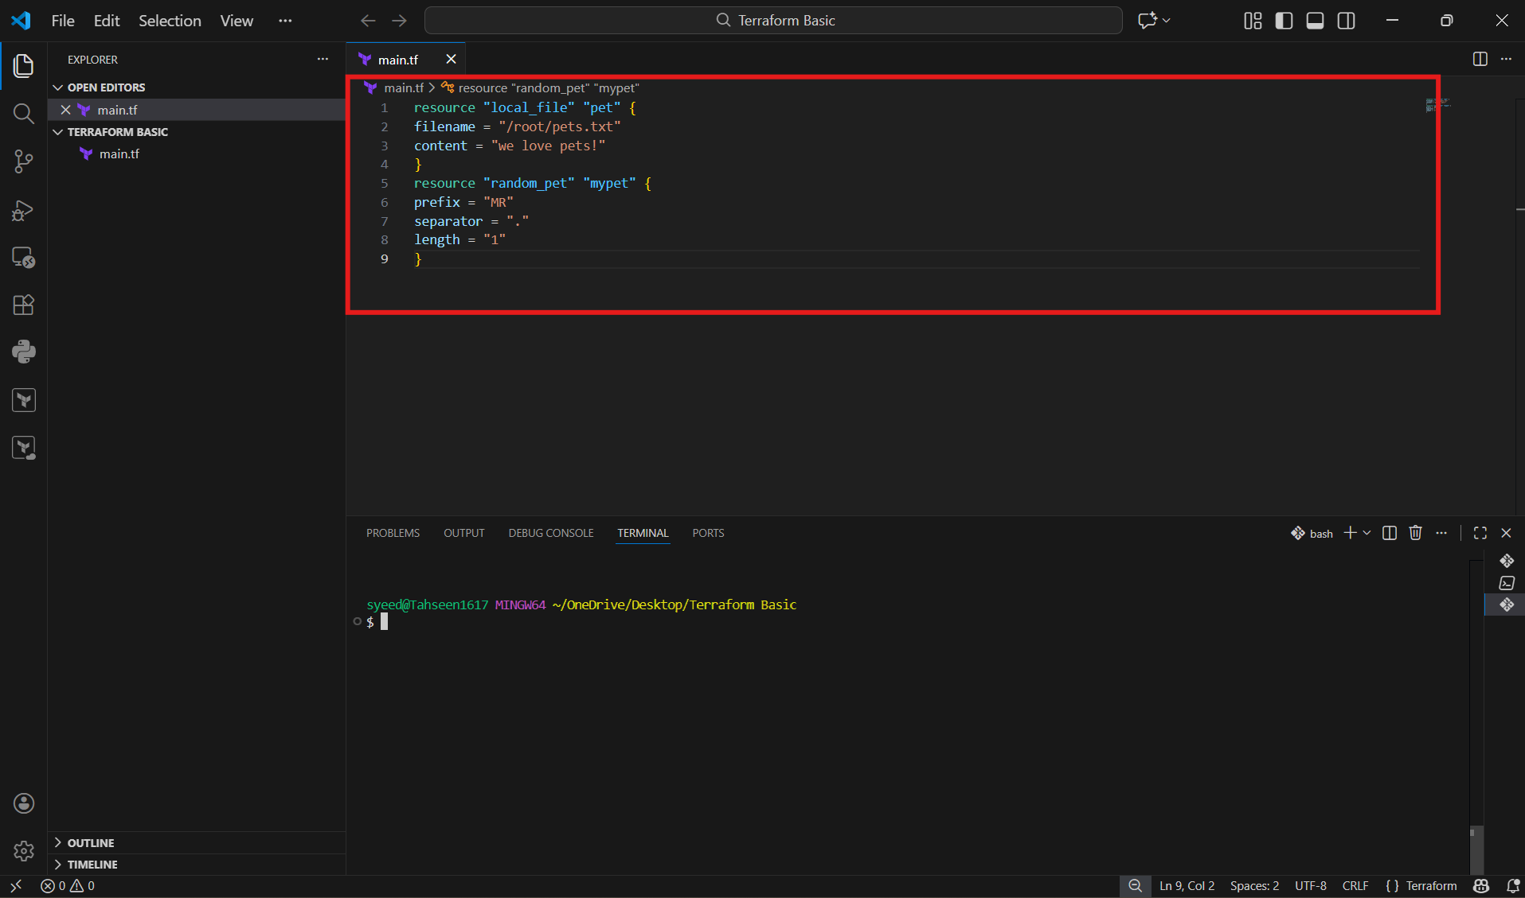
- terraform init is executed.
- Providers are downloaded:
  - hashicorp/local
  - hashicorp/random
- .terraform/ directory and .terraform.lock.hcl file are created.
- Terraform project is initialized successfully

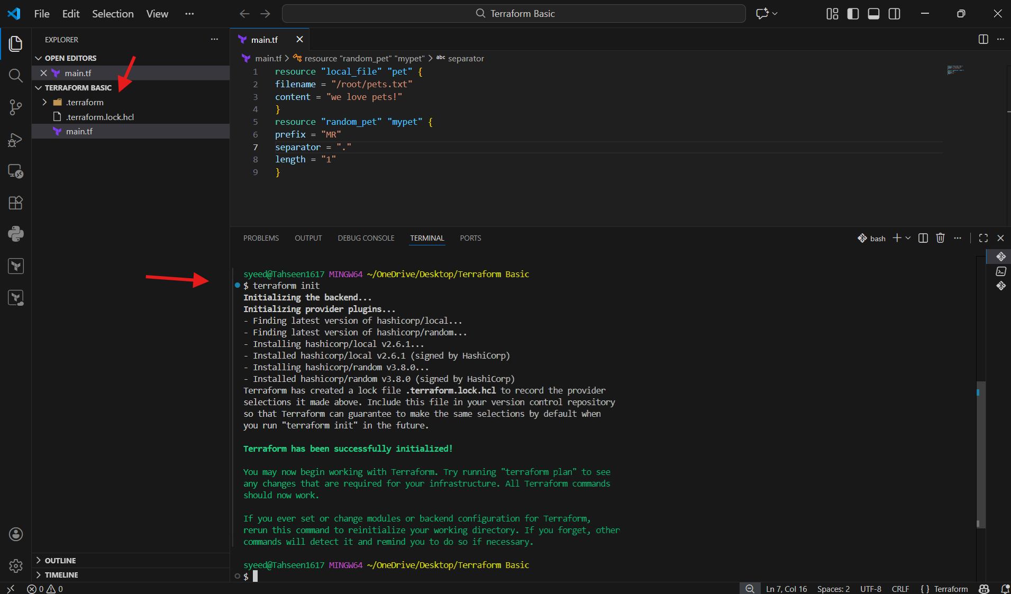
- Terraform shows an execution plan.
- Both resources will be created.
- You type yes.
- pets.txt file is created.
- random_pet value is generated

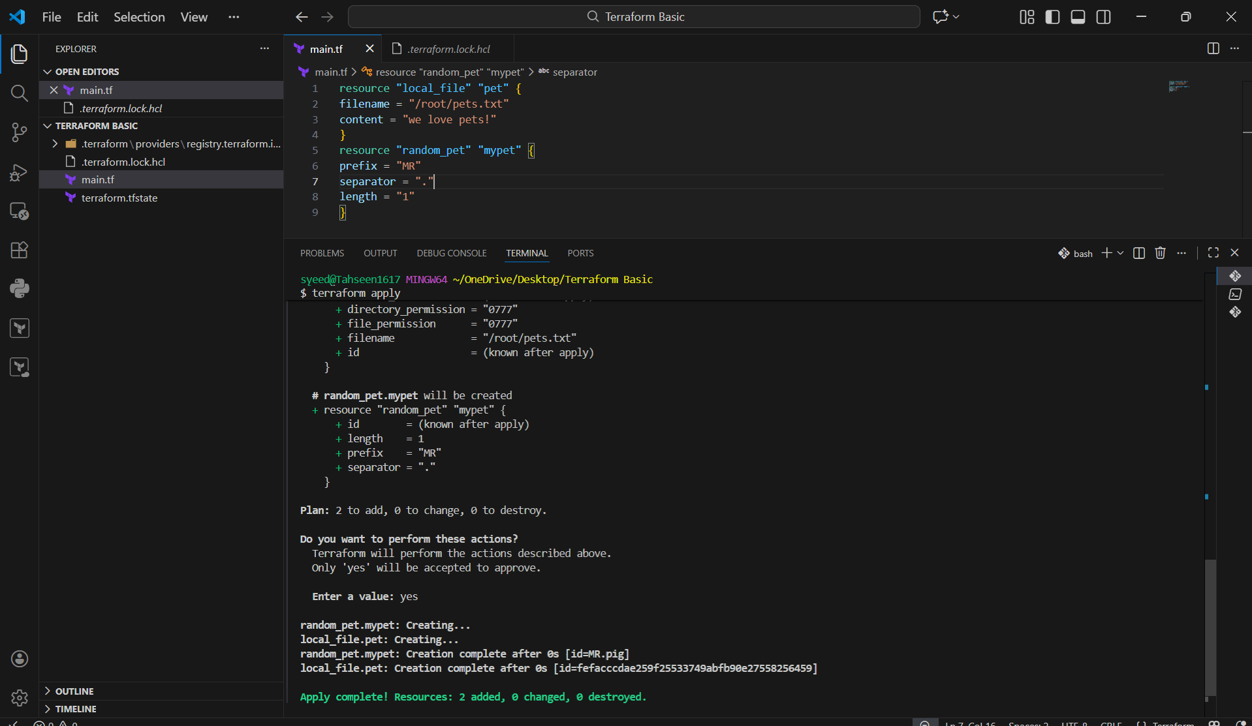
- terraform.tfstate file appears.
- State stores:
  - Resource IDs
  - File content hash
  - Provider metadata
- Terraform now tracks real infrastructure

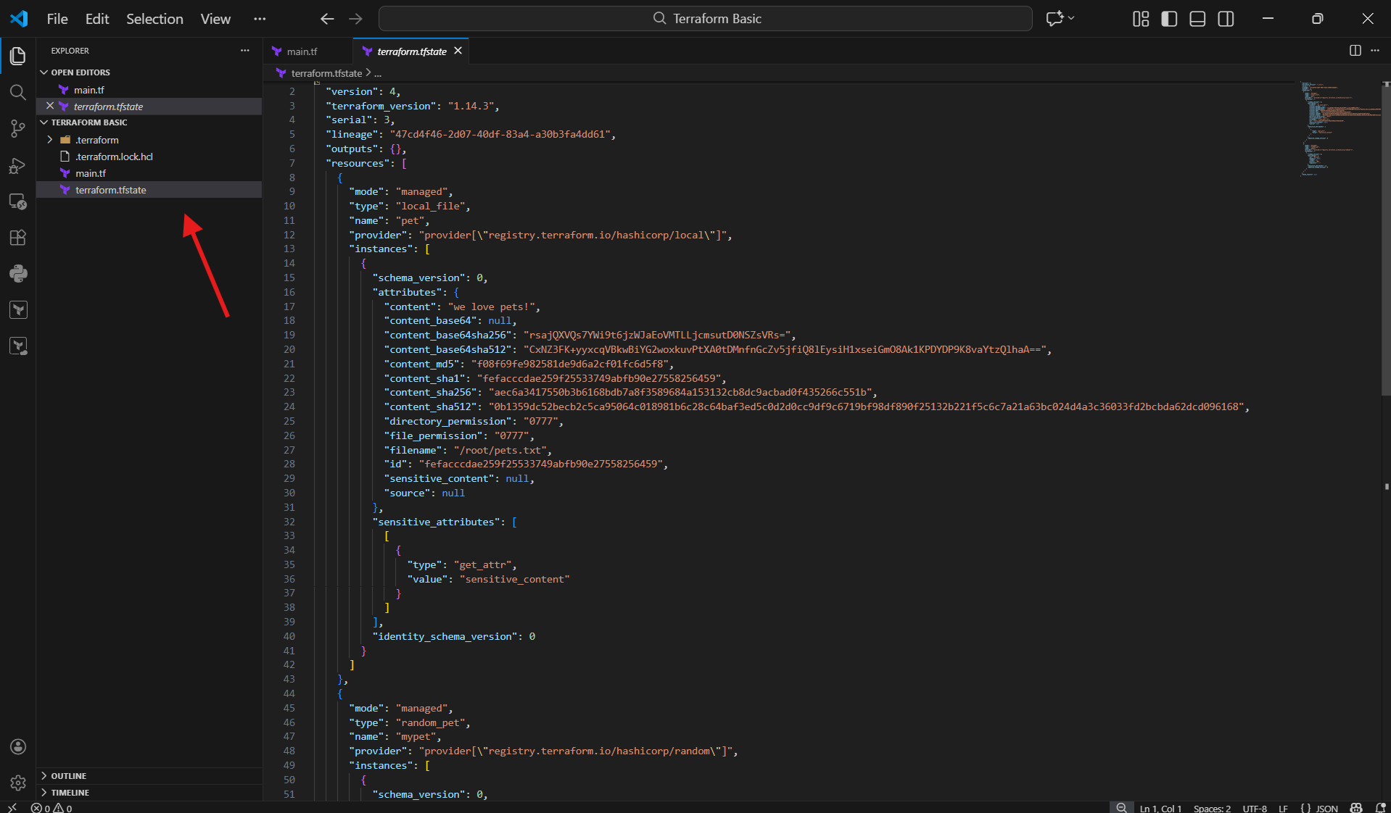

- modified content inside local_file.
- This causes a ForceNew change.
- Terraform detects drift between config and state

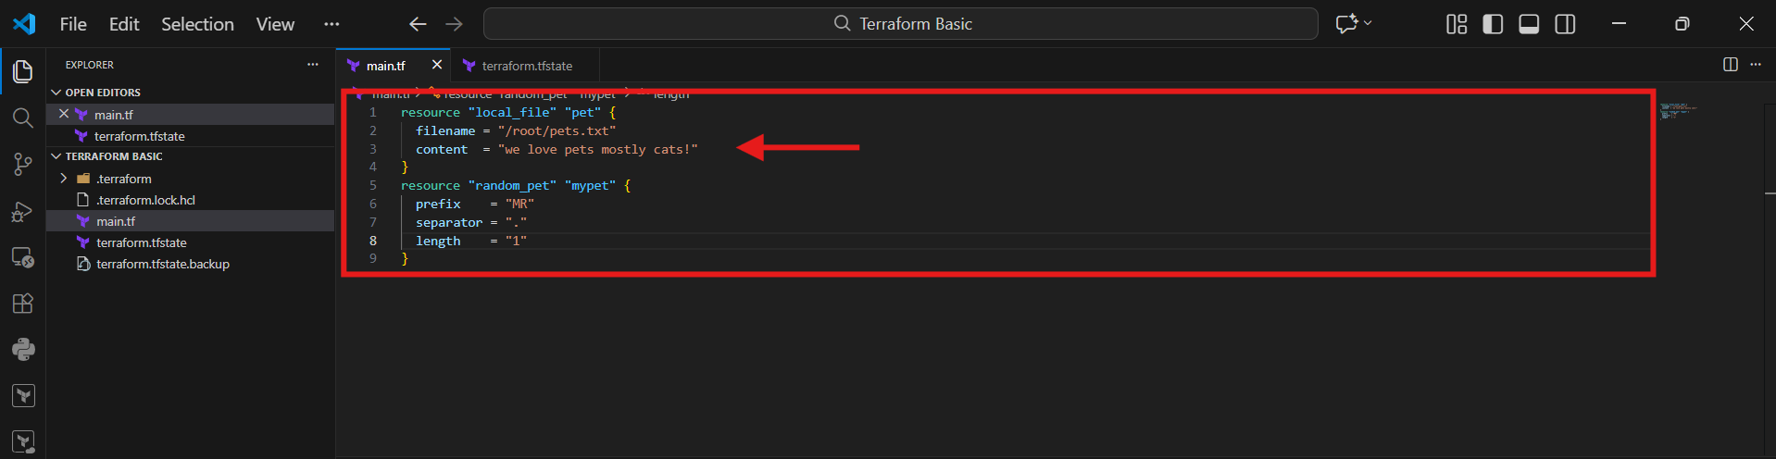
- Plan shows:
  - local_file.pet must be replaced
- Old file is destroyed.
- New file is created.
Key point
- Default behavior = destroy → create

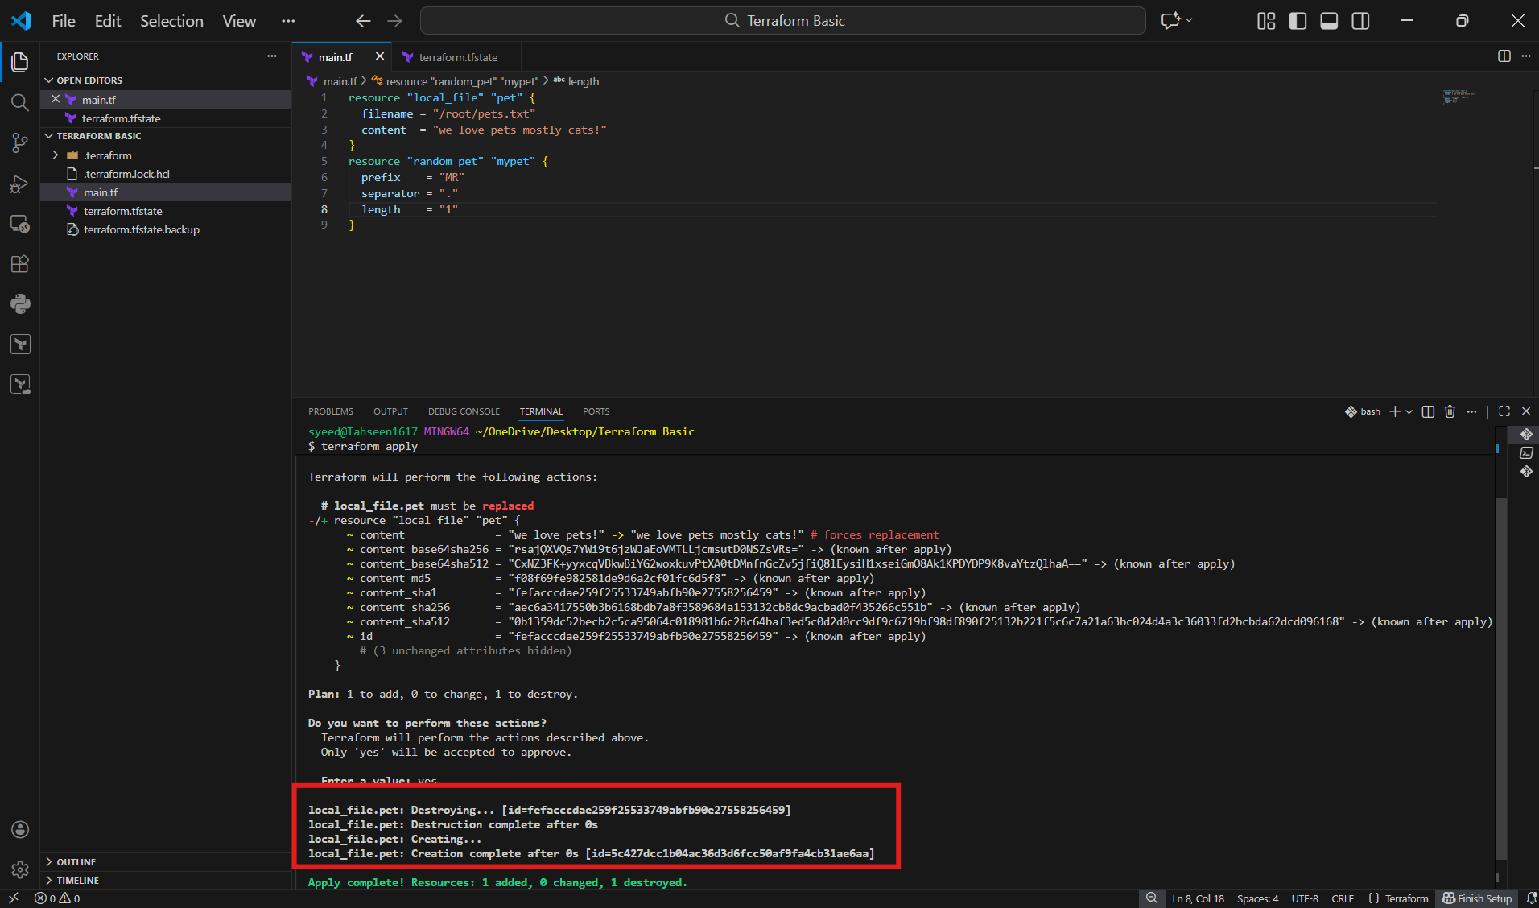
- added:
- lifecycle {
- create_before_destroy = true
- }
Key point
- Ensures zero downtime replacement.

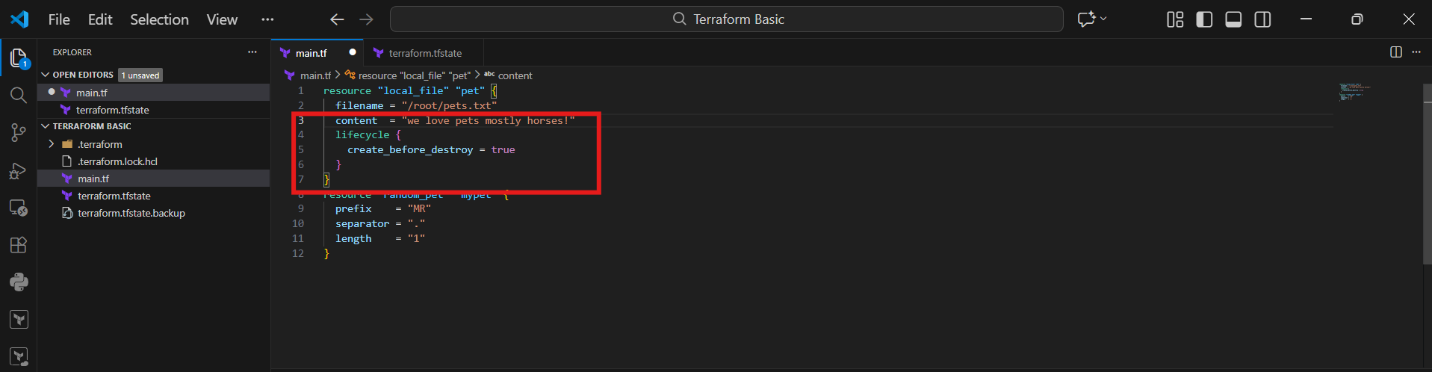
- New file is created first.
- Old file is destroyed after.
Key point
- Safe replacement strategy.

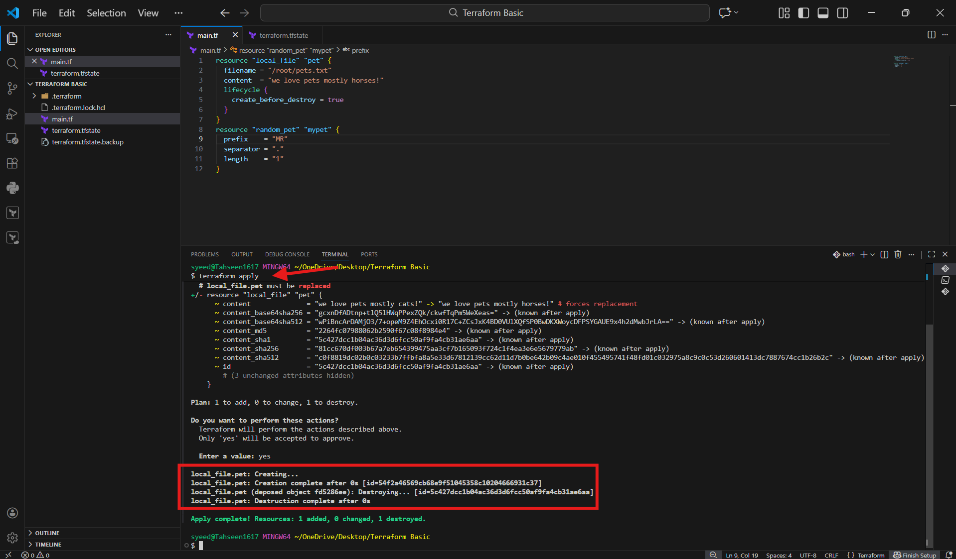
- added:
- lifecycle {
- prevent_destroy = true
- }
Key point
- Protects critical resources from deletion.

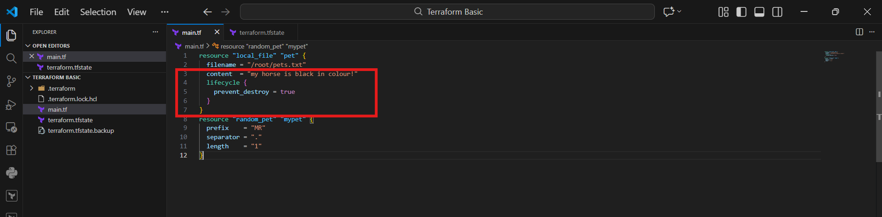
- Terraform refuses to destroy the resource.
- Apply fails if replacement is required.
Key point
- Manual intervention required to remove protection

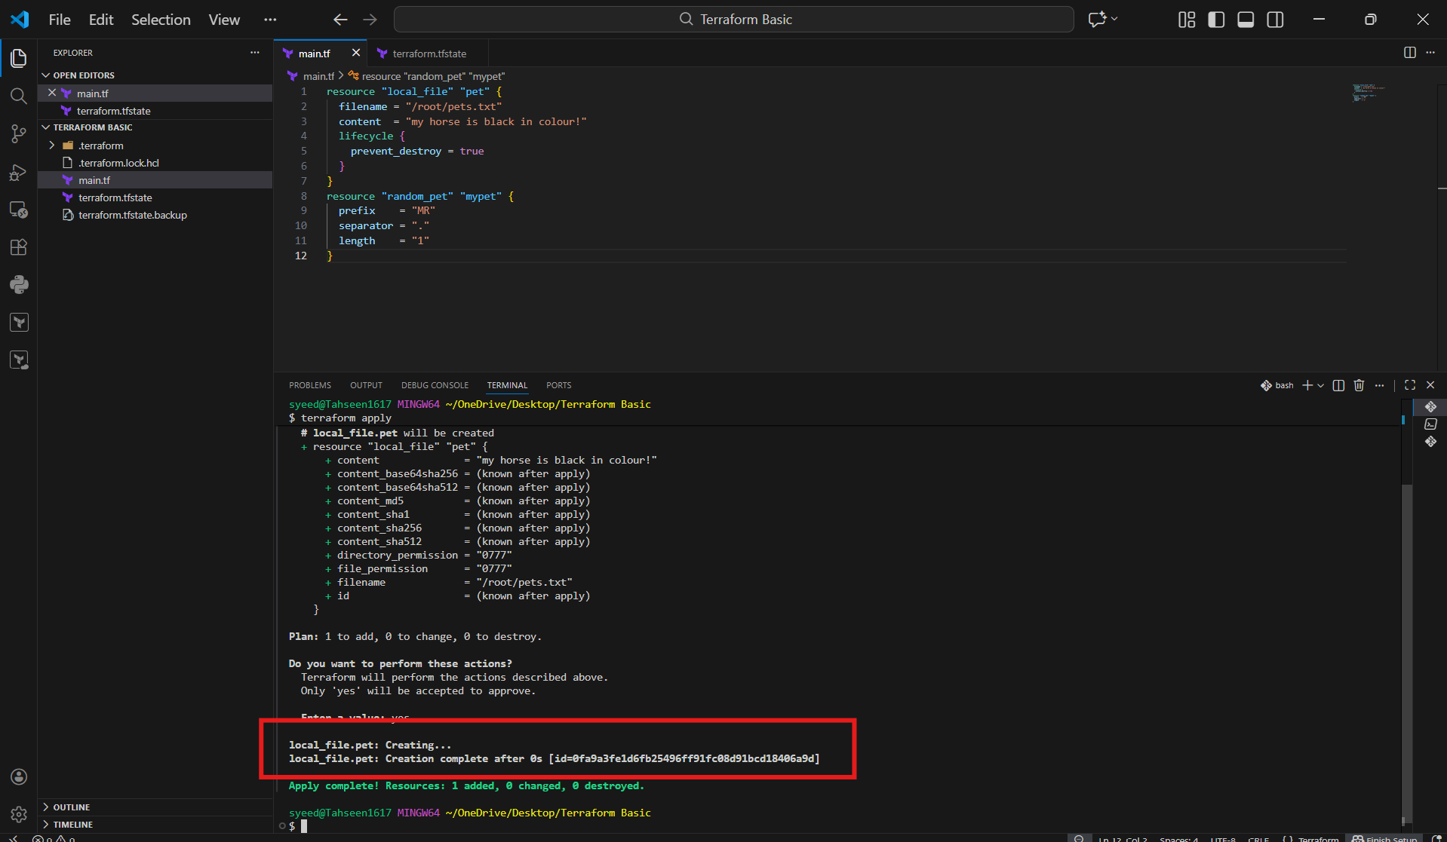

- Created a new file called variables.tf
- Defined reusable input variables:
  - pet_filename
  - pet_content
  - random_pet_prefix
  - random_pet_separator
  - random_pet_length
Key points
- Each variable has:
  - description
  - type
  - default
- Defaults allow Terraform to run without passing values manually

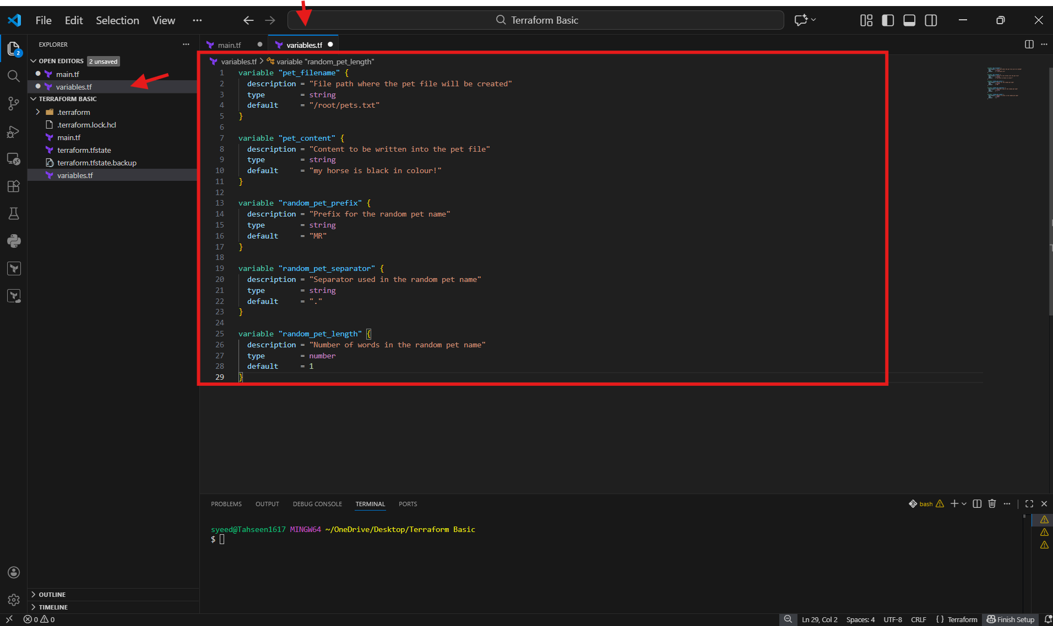
- Replaced hardcoded values with variables:
- filename = var.pet_filename
- content = var.pet_content
- Updated random_pet resource:
- prefix = var.random_pet_prefix
- separator = var.random_pet_separator
- length = var.random_pet_length
Key points
- var.<variable_name> is how Terraform references variables
- Configuration becomes dynamic and reusable

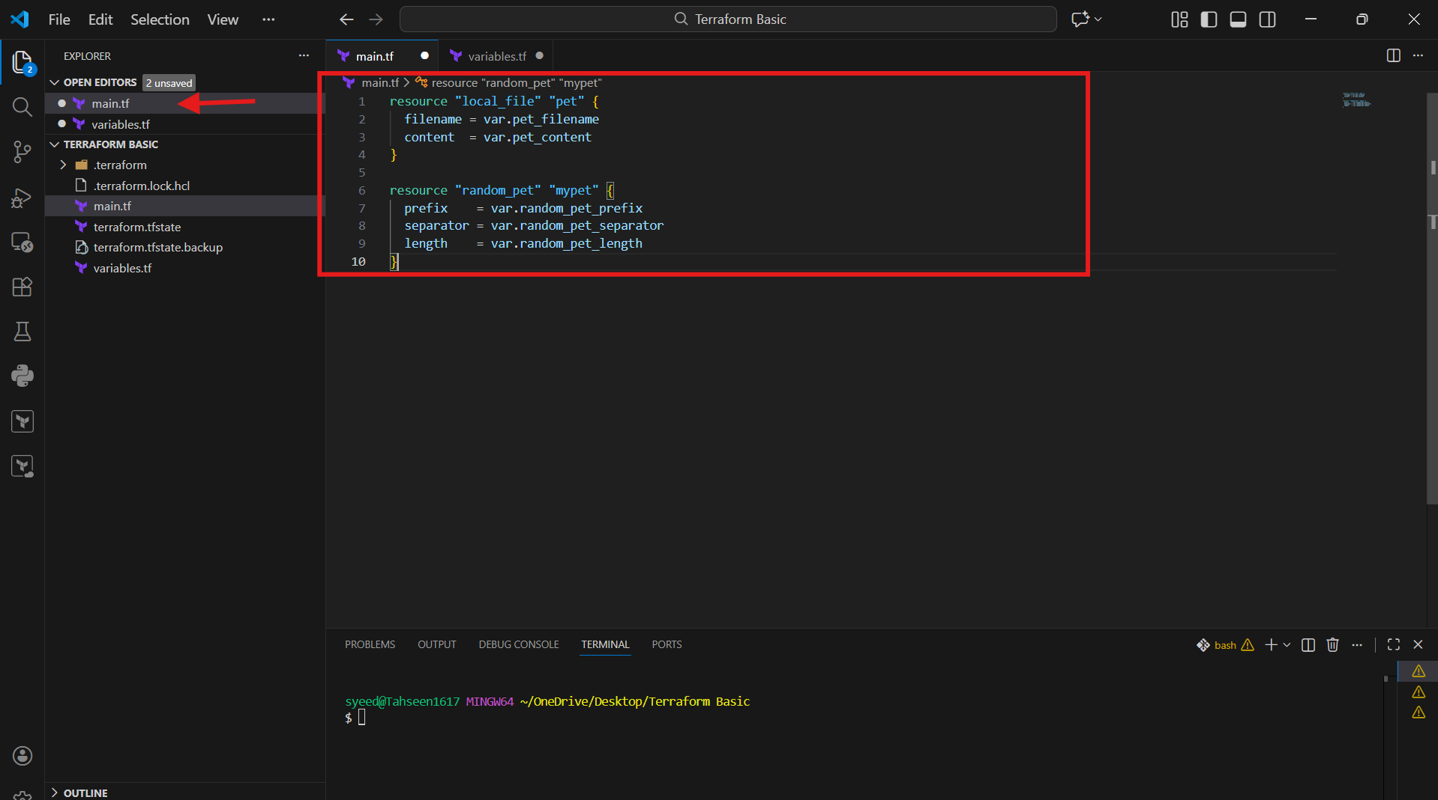

terraform apply
Terraform shows:
local_file.pet → will be created
random_pet.mypet → will be created
Plan: 2 to add, 0 to change, 0 to destroy
No existing resources found in state
Terraform prepares to create new resources
Enter a value: yes
Terraform requires explicit approval before making changes
This prevents accidental infrastructure modification
random_pet.mypet created first
Generates value: MR.muskox
local_file.pet created next
File path: /root/pets.txt
Content taken from variable

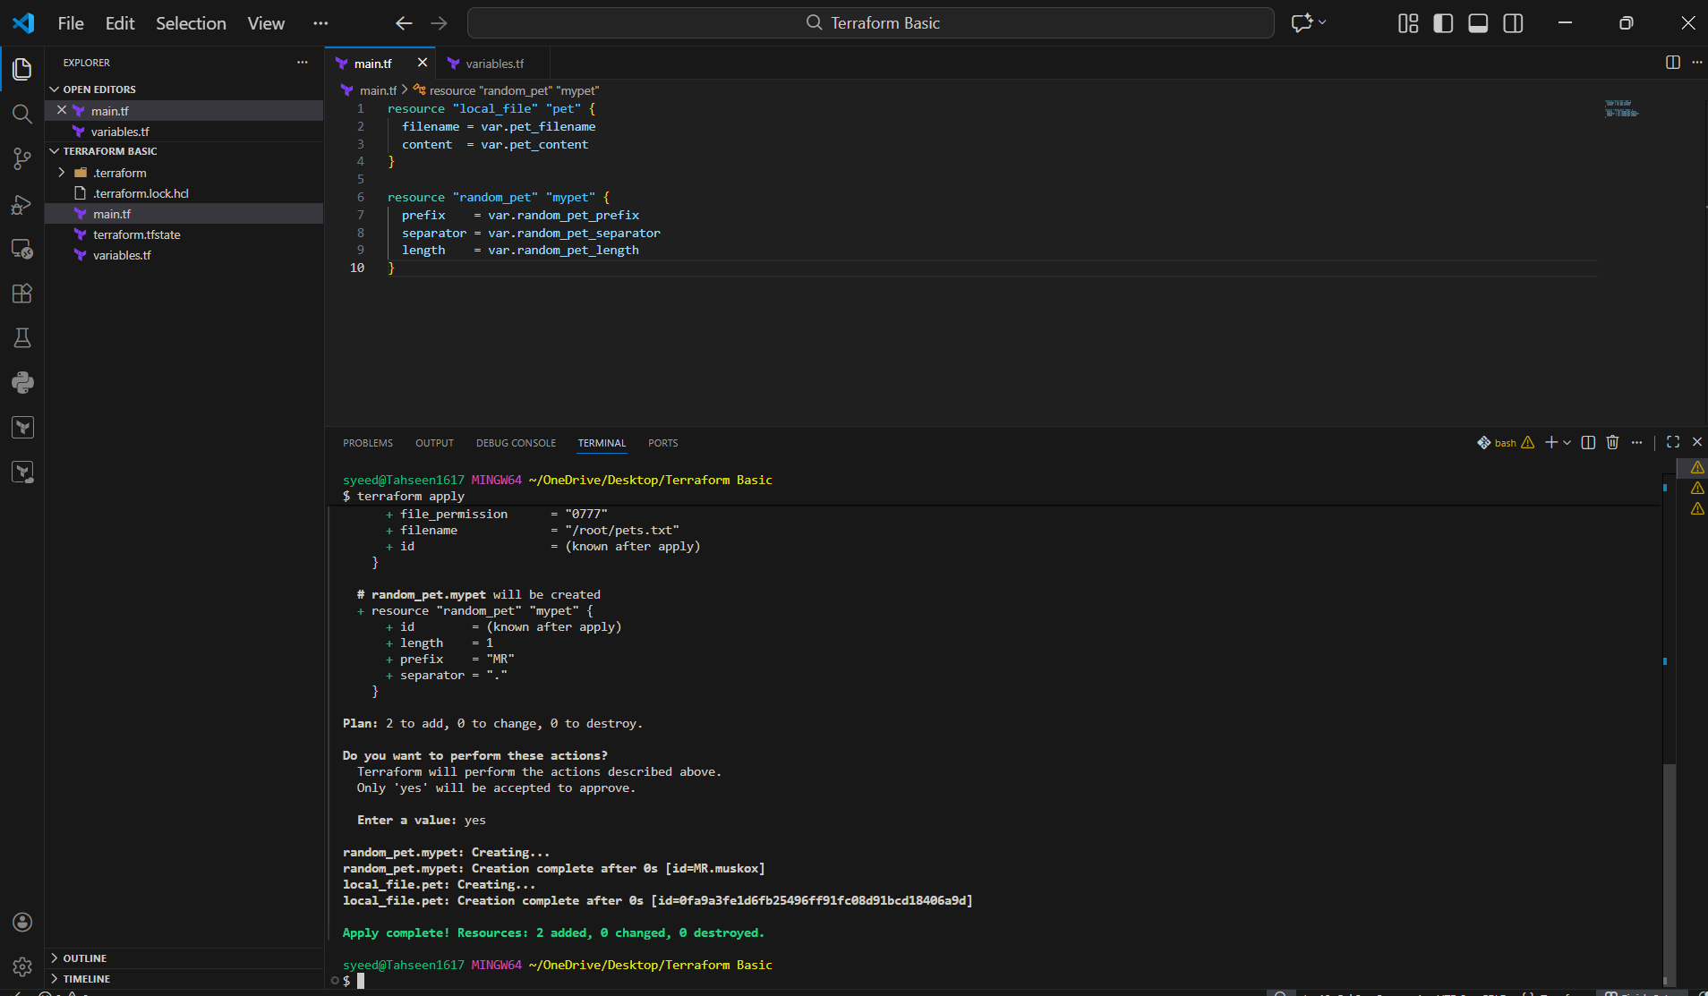

- Integrate Terraform in Jenkins using the Terraform plugin

- opened main.tf directly in GitHub.
- local_file and random_pet resources reference variables using var.*.
Why this matters
- No hard-coded values.
- Configuration is reusable and CI/CD friendly.

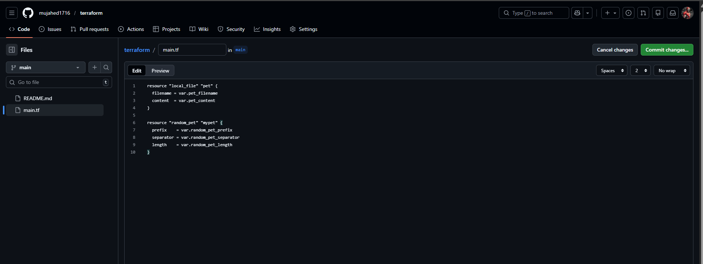
- defined all input variables:
  - pet_filename (now /tmp/pets.txt)
  - pet_content
  - random_pet_prefix
  - random_pet_separator
  - random_pet_length
Why this matters
- Fixes Jenkins permission issue.
- Ensures Terraform config is valid

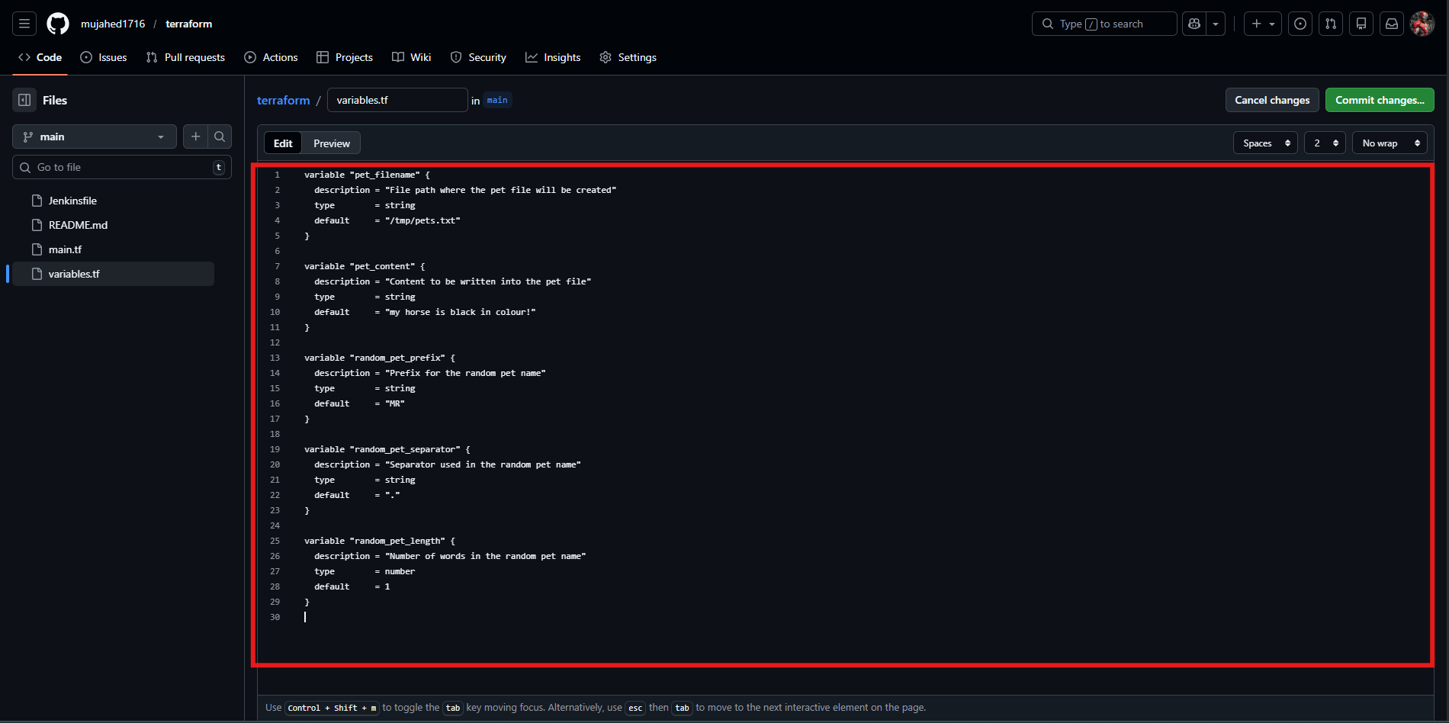
- created a file named Jenkinsfile
- Pipeline stages included:
  - Checkout
  - Terraform Init
  - Terraform Plan
  - Terraform Apply (manual approval)
Why this matters
- Jenkins reads pipeline directly from SCM.
- Follows DevOps best practice (pipeline as code)

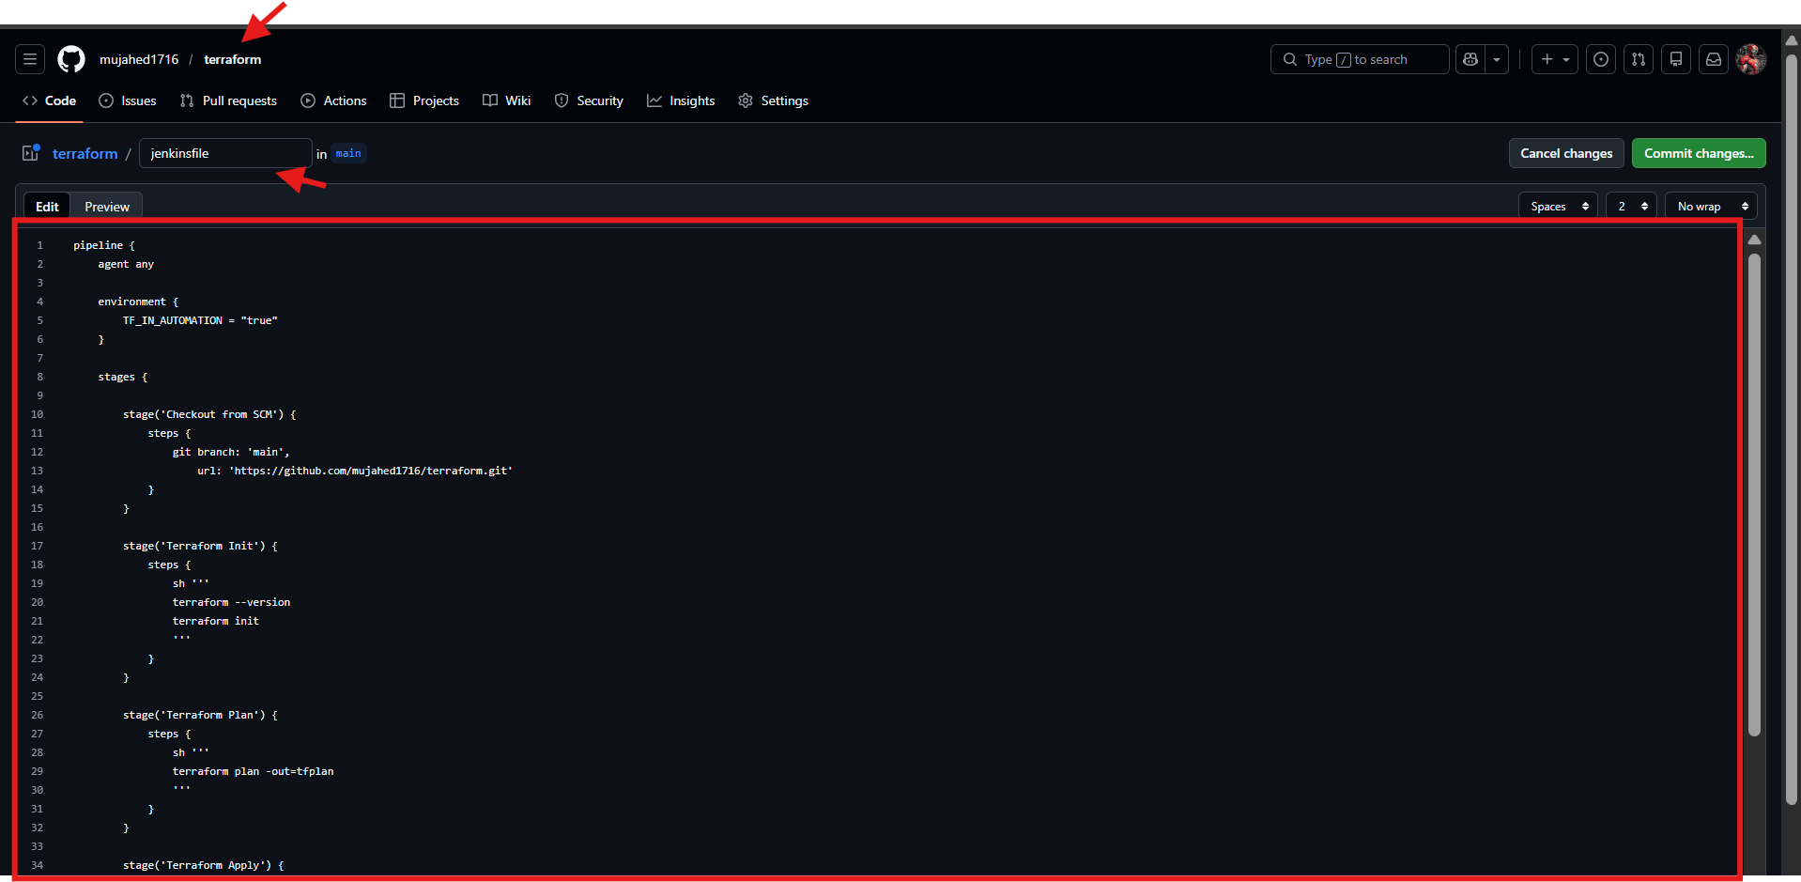

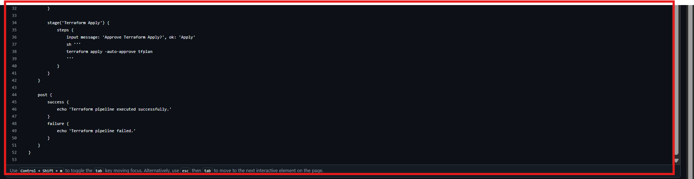
- jenkins → New Item
- Job name: terraform-pipeline-task-02
- Job type: Pipeline

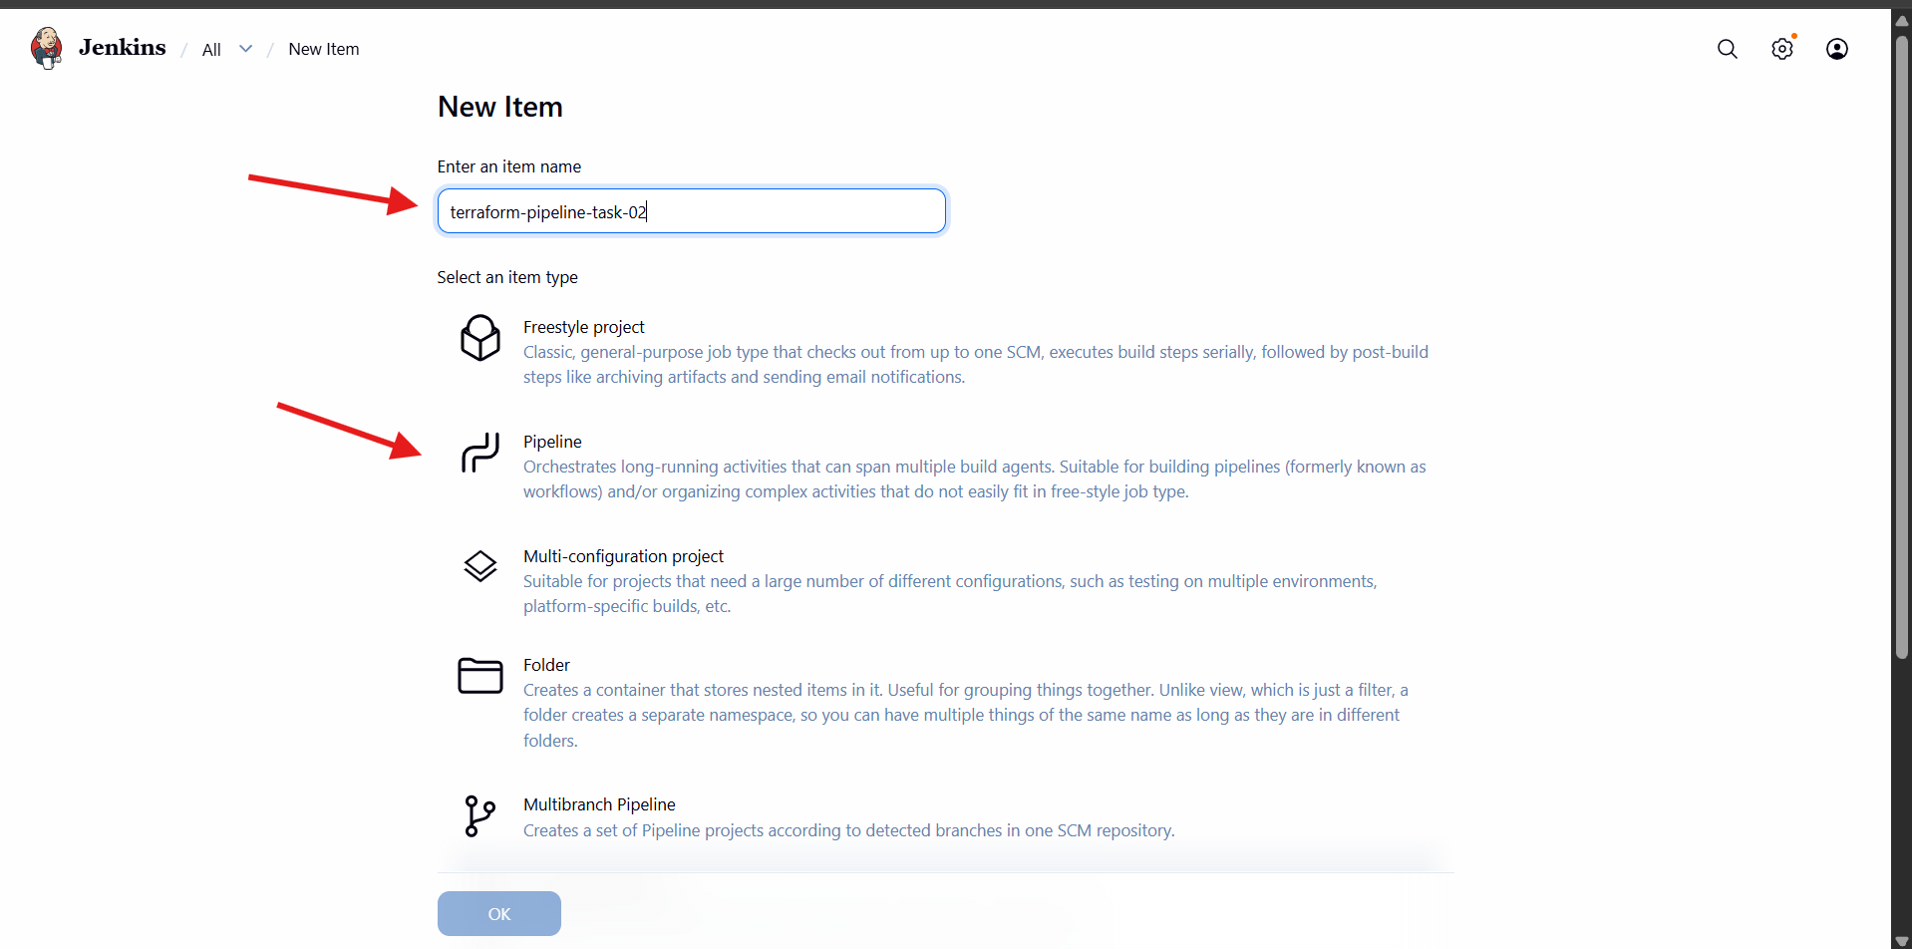
- Definition: Pipeline script from SCM
- SCM: Git
- Repository URL:
- https://github.com/mujahed1716/terraform.git
Why this matters
- Jenkins automatically fetches pipeline code from GitHub.

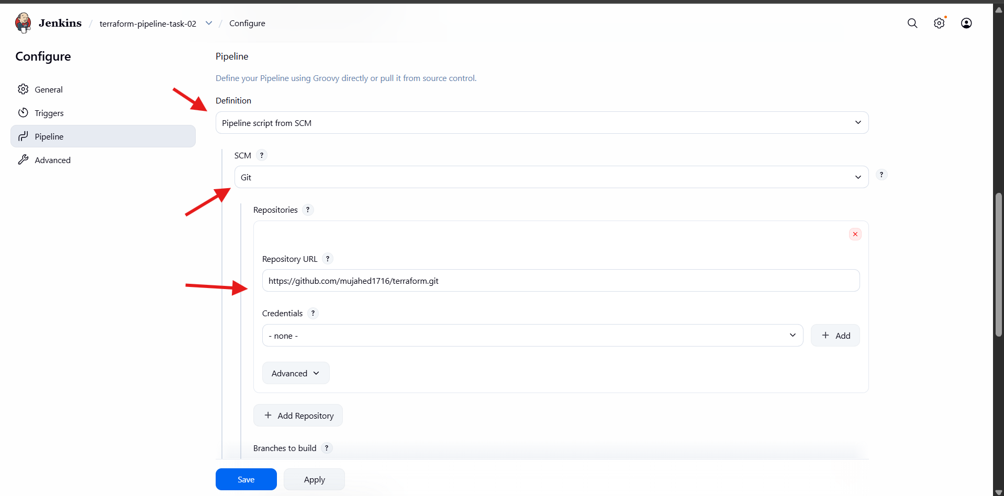
- Branch Specifier:
- */main
- Script Path:
- Jenkinsfile

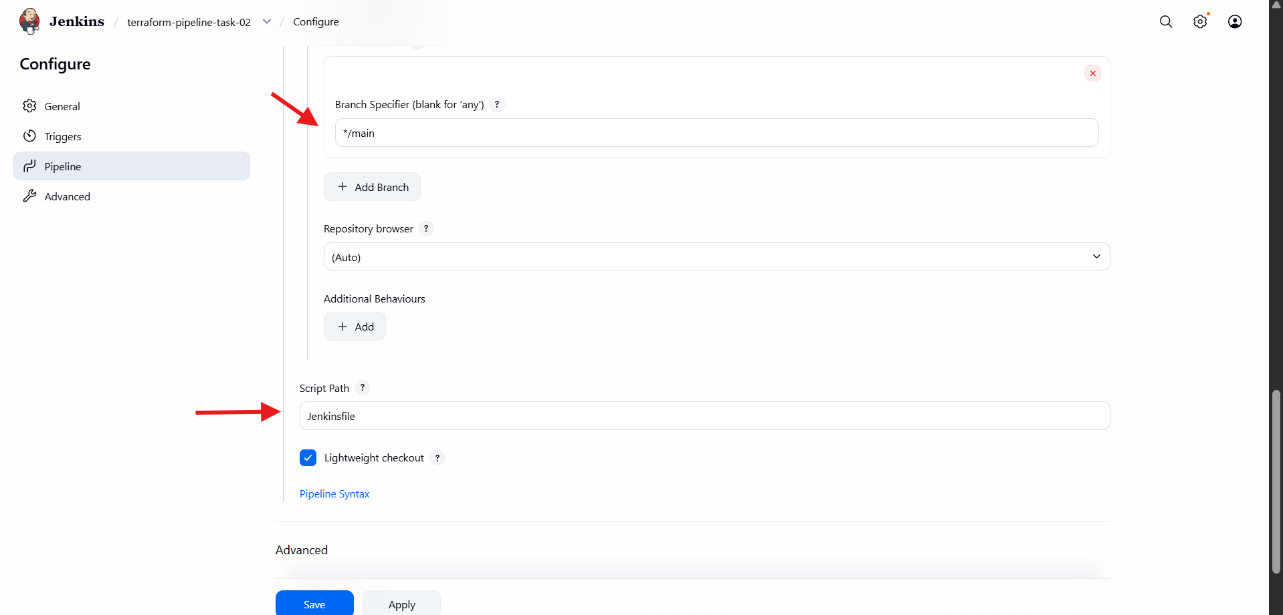
- Build is triggered manually.
- Jenkins performs:
  - Git checkout
  - terraform init
  - terraform plan
  - Manual approval
  - terraform apply
Result
- Resources created successfully.
- File written to /tmp/pets.txt.
- Random pet name generated.

